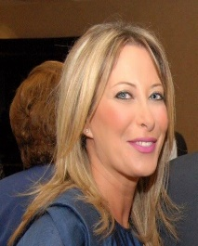 **Ghada Ayoub Bou Fadel**

* PhD in Law
* University Diploma in International Nuclear Law
* Assistant Professor at the Lebanese University, Faculty of Law and Political Sciences.
* Legal advisor at the Lebanese Atomic Energy Commission, CNRS.
* DAOF Committee Chair RY 2018-19
* PE Rotary Club of Saida
* Vice President of Saida International Marathon Association
* Married to Elie Bou Fadel and mother of two young man Jean-Paul and Karl.